Kinetic Minds
At Home Program
3:00-6:00 PM
A Quick Look
Science  Week 1: How strong is a piece of paper?  Week 2: Seed in a jar  Week 3: Carrying cargo on a paper airplane  Week 4: Seed in an eggshell | Technology  Week 1-District Website Focus  https://kids.nationalgeographic.com/  Week 2-District Website Focus https://www.funbrain.com/games/tinybop-schools-coral-reef  Week 3-District Website Focus https://classroommagazines.scholastic.com/support/learnathome.html  Week 4- District Website Focus https://pbskids.org/games/
Engineering  Week 1- Binary Bracelet  https://girlswhocode.com/code-at-home/  Week 2- Scavenger Build  Week 3-Paper Tower  Week 4- Gyrocopter | Art  Use a 5x7 piece of paper and create a picture using crayons, markers, colored pencils, pens or inks.  Week 1 Prompt-Earth  Week 2 Prompt-Water  Week 3 Prompt-Air  Week 4 Prompt-Fire
Math  District Website-Complete Homework, use District Additional Math Websites.  For fun try….  https://www.brainpop.com/ for fun math activities! | Reading  District Website-Complete Homework and use District Additional Reading Websites such as Rally Round Reading  https://www.footsteps2brilliance.com/  For fun try…. the TEPSA Nightly Book Reading for your good night book!  www.facebook.com/tepsatalk/videos
everything  Week 1- Relaxing tips  Yoga: Relaxation pose  Week 2- Being Bored  Yoga: Mountain Pose  Week 3- Ignoring Distractions  Yoga: Butterfly Pose  Week 4- Helping Adults  Yoga: Warrior Pose | else  Week 1- 5 push-ups, 10 sit-ups, 25 jumping jacks  Week 2- 10 push ups, 15 sit-ups, 30 jumping jacks  Week 3- 10 push ups, 20 sit-ups, 30 second run in place  Week 4- 15 push ups, 20 sit-ups, 1 min run in place

The Details

Science:
Week One: Materials and Process-3 pieces of paper, tape, books. Fold the paper into 3 columns, a triangle, a square and a cylinder. Slowly place books on top of each shape. Talk or write down your results and compare the strength of your 3 columns.
Week Two: Materials and Process: A jar, paper towel, one seed and water. Place a damp paper towel with a bean seed and place in the jar. Put the jar in a warm spot with sunlight. Each day talk or write down your results.
Week Three: Materials and Process: Paper, tape, coins. Draw a line on the floor about ten feet in front of a door. Tape coins to the top of paper airplane. Try to fly your airplane 10 feet. Add more coins. What is the most cargo that your plane would carry 10 feet? Talk or write your results.
Week Four: Materials and Process: Egg shells, Soil, Seeds, Water, Spoon. Fill egg shells with soil and plant seeds in the egg shells between ¼" to ½" in depth. Keep moist and record the date planted, when the seeds sprouted and any other observations.
Technology; See District Additional Website Page compiled below for your convenience.
Engineering:
Week 1-Binary Bracelet https://girlswhocode.com/code-at-home/
Week 2- Scavenger Build-Find cool objects in your home or yard with the help of a parent and create your “Ideal Classroom”. Use your imagination and think outside the box.
Week 3-Paper Tower-Using only 5 pieces of paper, tape and scissors, create the tallest tower ever!
Week 4- Find a cool building or structure online. Then, try to figure out how it was made, what materials they used, how long it took, what kind of skills workers needed to build it.
Art: Follow the simple instructions on the previous page.
Math: District Website-Complete Homework
Reading: Follow the simple instructions on the previous page.
everything: See additional attachments for social skills and yoga!
else: Follow the simple instructions on the previous page.
For every Kinetic Minds category, you have the opportunity to win a badge. You and an adult will sign the log page after you complete each category. For each category there are four tasks. You must complete each task to master that category. There are eight categories. So you have the potential of winning 8 badges per four week period. If you complete all 8, you will be a Grand Jedi Master and will receive a special badge. The badges will be virtual initially, and when you return to Kinetic Minds you will receive your badges in a special ceremony on your campus.
Everything! (Social Emotional and Yoga)
Relaxing Tips
Think: Do I need to relax? Do I feel nervous, tense, queasy or jittery?
Do: Take three slow, deep breaths (breathe in through your nose and out through your mouth).
Do: Tighten one part of your body, count to three, and relax (for example, your stomach, legs, or feet).
Do: Continue tightening and relaxing each part of your body.
Think: Ask yourself how you feel?
Being Bored
Think: Am I bored? Do I know what I want to do? Do I feel jittery or anxious inside?
Think: Think of things you like to do.
Decide: Decide on one thing to do.
Do: Do the thing you decided to do.
Think: I did a great job doing something on my own!
Ignoring Distractions
Think: In your mind, count to five. Counting to five will give you the time to calm down if frustrated.
Think: I will keep working on my project or task. I won’t look at the distraction.
Do: Keep working on your task or project. Sometimes it helps to talk out loud to yourself about your steps.
Think: I did a great job working on my project!
Helping Adults
Think: Does the adult need your help?
Think: How can you ask them if they need help? For example, “Can I help you do that?”
Think: Is this a good time to offer help? Can you really help now, or are you supposed to be doing another chore or homework?
Ask: Ask the adult if you can help. If they say yes, then help!

Yoga Poses
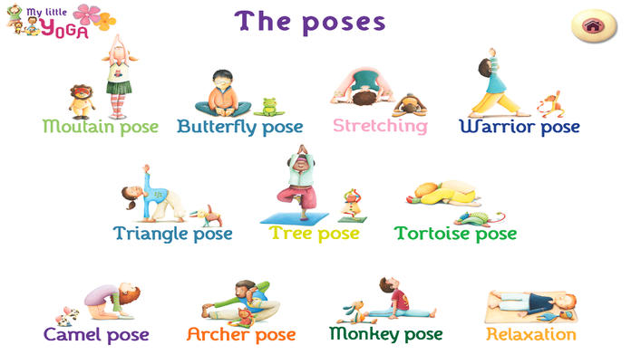

District Additional Websites Compiled for YOU!

