Books  K= I am a Community Worker  1st=  2^{nd=}  3rd =Last Day of School  What does It Mean to be Brave? | Books  Read your level book for 15 minutes online  1 point | Study  your spelling words for 10 minutes  1 point | Write  What do EMS workers do?  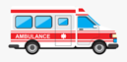  1 point | Timed  Have parents time you reading your assigned book  1 point
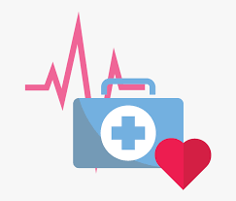 | Write  two sentences about health.  1 point | Read  one of your leveled books for at least 15 minutes  1 point | Write  what you do to stay healthy.  1 point | Listen  to one of the suggested YouTube videos  1 point
IXL  Must complete 1hour per day of IXL Math. Math problems have been loaded on IXL. Look for the | Practice  starred assignments in IXL for at least 30 minutes  1 point | FREE  Complete ALL of the bingo space!  3 POINTS | Create  3 math problems with answers  1 point | Freestyle  pick any 3 activities on your grade level from IXL, RAZ Kids, or bingo.  1 point
Spelling Spot  See teacher’s list on the Kinetic Minds website for your spelling words | Draw  a picture that shows something relating to health.  1 point | Share  your definition of health.  1 point | Study  your spelling words for 10 minutes  1 point | Write  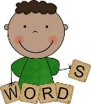  your spelling words 3 times  1 point
Buddy | Why did the banana go to the doctor’s office?  3 points | Answer for your grade  K= 2+7=  1st= 15+5=  2nd=Quarter past 12 is ?  3rd = 2x + 3=11  3 points | Name one reason people go to the doctor?  3 points | What type of healthcare job would you do?  3 points
B I N G O
KINETIC MINDS WEEKLY B.I.N.G.O.

